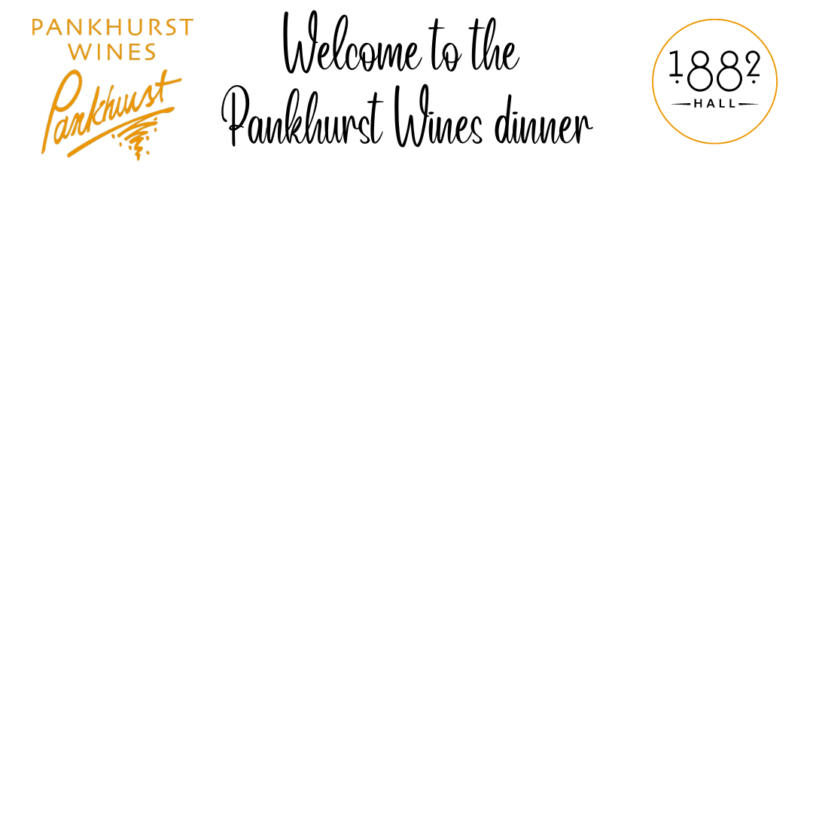  House baked focaccia with truffle butter  Christabel Sparkling Pinot/Chardonnay  Fish roulade / nashi flake / pickled baby cucumber  Marsanne  Confit pork fillet / poached okra / pistachio herb crumb /  apple and plum jus  Tempranillo  Lamb tenderloin / smoked ham rice noodles /  baby bok choy / house made satay sauce  Dorothy May Cabernet Sauvignon  Honey roasted peaches / mascarpone and  double brie cream / candied walnut  Sangiovese Rose | House baked focaccia with truffle butter  Christabel Sparkling Pinot/Chardonnay  Fish roulade / nashi flake / pickled baby cucumber  Marsanne  Confit pork fillet / poached okra / pistachio herb crumb /  apple and plum jus  Tempranillo  Lamb tenderloin / smoked ham rice noodles /  baby bok choy / house made satay sauce  Dorothy May Cabernet Sauvignon  Honey roasted peaches / mascarpone and  double brie cream / candied walnut  Sangiovese Rose

